Title: Dietitian Liz
Recipe: Chocolate Peppermint Muffins
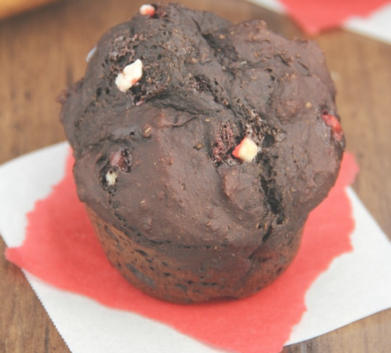
Christmas is right around the corner which means there are going to be many cookies, pies, and other desserts all around. To help ensure that you have a healthier option to choose from try making these chocolate peppermint muffins for any holiday celebration you may attend. Having about 150 calories less than your typical muffin and lower amounts of added sugar, these treats will help you keep your waistline in check during the holiday season all while satisfying your sweet tooth.

Ingredients:

- ¾ cup plain nonfat Greek yogurt
- 1 cup nonfat milk
- 1 ½ tbsp. vanilla extract
- 1 tsp peppermint extract
- ½ cup granulated Splenda (or granulated sugar)
- 2 tsp Truvia
- ¼ cup peppermint baking chips

- 1 cup all-purpose flour
- 1 cup whole wheat flour
- 1 ¼ cup unsweetened cocoa powder
- 1 ½ tsp baking soda
- 1 ½ tsp baking powder
- ¼ tsp salt
- 2 eggs, lightly beaten

Directions:
- Preheat the oven to 425°F, and coat 12 muffin cups with nonstick cooking spray.
- In a medium bowl, whisk together the all-purpose flour and next 5 ingredients (through salt). In a separate bowl, whisk together the eggs, yogurt, milk, vanilla, and peppermint extract. Stir in the Splenda and Truvia. Add in the flour mixture, stirring just until incorporated. Gently fold in the peppermint baking chips.
- Divide the batter between the prepared muffin cups. Bake at 425°F for 6 minutes. Without opening the oven door, reduce the heat to 325°F and bake for another 11-13 minutes, or until a toothpick inserted into the center comes out clean. Cool in the pan for 10 minutes before turning out onto a wire rack.

Recipe altered from: https://amyshealthybaking.com/blog/2013/12/20/chocolate-peppermint-muffins/

